Admin Panel
Edit profile fine but we don’t need DOB.
There should be individual names but several can have access to admin, and can be called admin but perhaps have their name in brackets eg admin (amina) or Admin (A Alhakim)

Otherwise fine but need to add similar items to doctors eg change password etc

Jobs list change to “dashboard”, but the dashboard is that is loaded up after log in- so home page- logos similar to doctors panel

Dashboard items:
Urgent cases outstanding
Routine cases outstanding- 1 week, 1-2 weeks etc
Number of cases authorized
Cases booked in but not allocated to doctor yet
Doctors who are logged in- with a number
I think you have included these in the select button:-
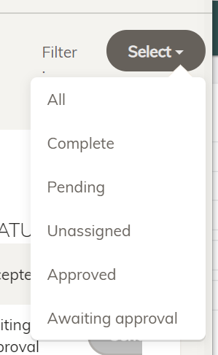

but better to have a separate dashboard like a big button with a number
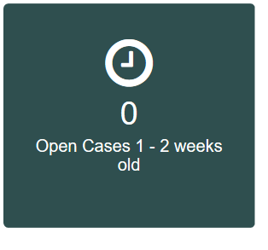
There should be a search button that would include similar items to these (I think we already agreed them):
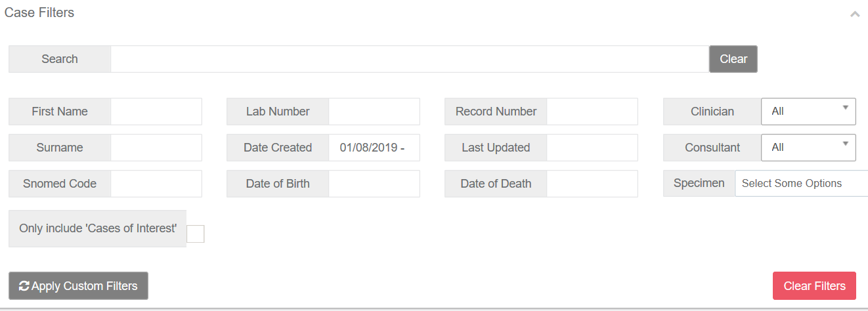

So we can search what cases are more than 3 weeks old
How many cases does doctor A need to do etc

In terms of this, change add existing job to Edit existing job
And Add job change to Add new job
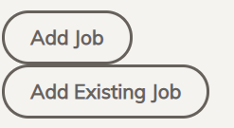

But this already included in:
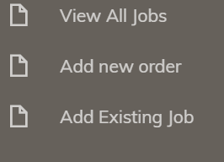- so is there a need to have that again?

When viewing all jobs:
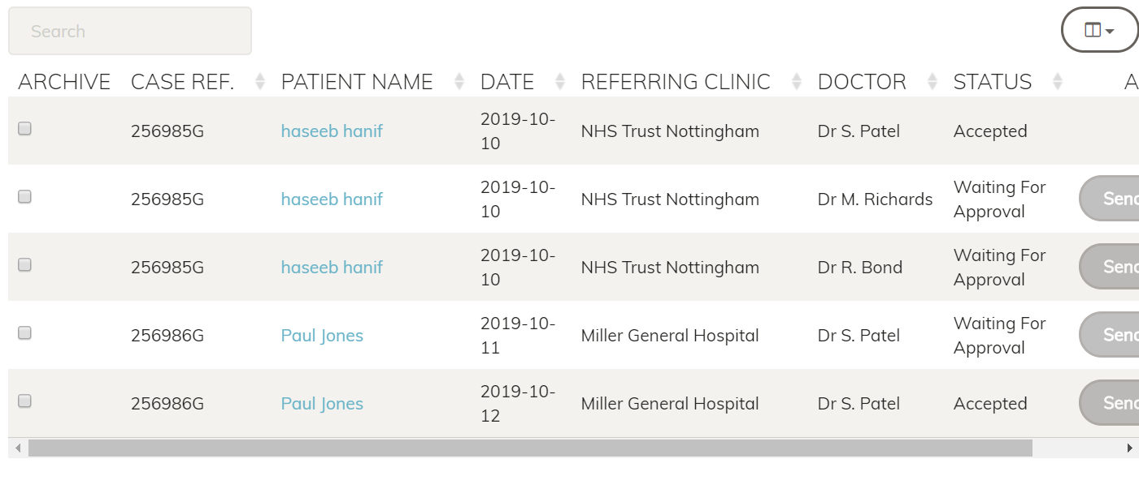

There should be an item to view report by web and by word and pdf in case hospitals ask admin to send them a report.

Message thing really good.

